Permanence Service Plan 2022 - 2026
Lancashire's Permanence Service for children in our care and care leavers
May 2022

Contents

1. Introduction to Lancashire's Permanence Service 3

1.1 Our Vision, Mission & Values 4

1.2 Our Core Principles for working with children, young people and their families 4

1.3 Our Teams 5

2. Our Priorities 6

2.1 Corporate Parenting Strategy 12

2.2 Sufficiency Strategy 13

2.3 Lancashire's Promise 13

3. Governance 13

4. Performance Management 14

5. National Policy Context 14

6. Review 15

Introduction to Lancashire's Permanence Service

Lancashire's Permanence Service for Children in Our Care and Care Leavers is part of Lancashire's Children's Services promoting a sense of belonging, security, continuity, support and stability for children and young people whose plan of permanence is to remain in our care, and for care leavers.

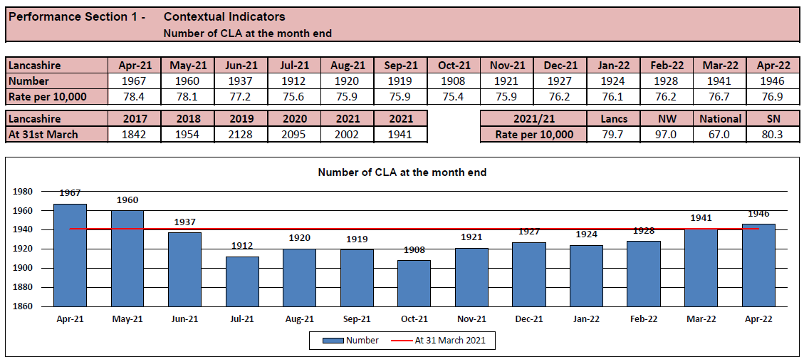

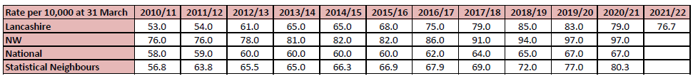

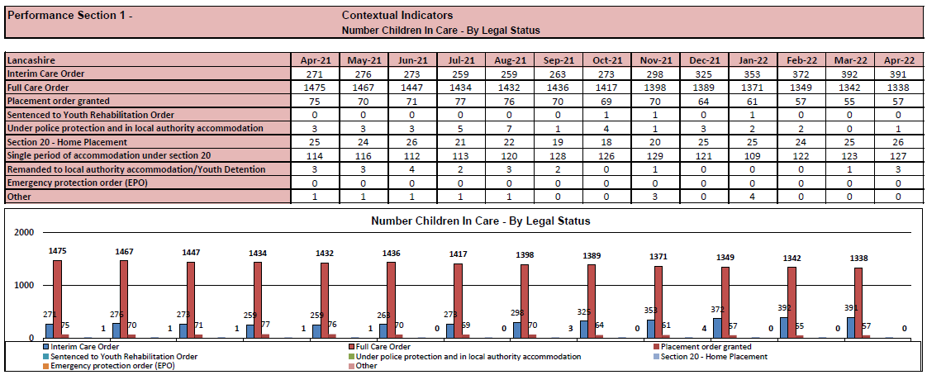

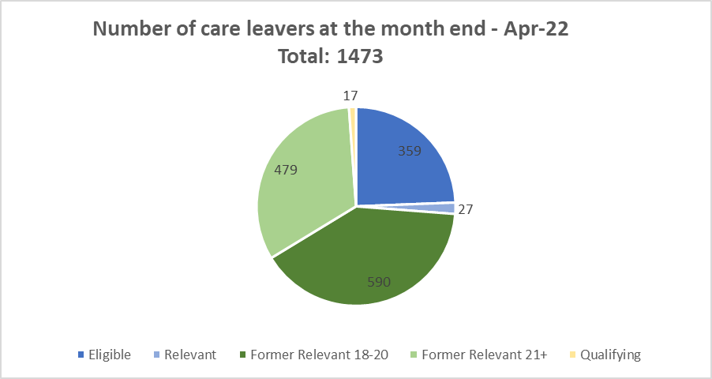

1.1 Our Vision, Mission & Values

Our vision in Education & Children's Services is for children, young people, and their families to be safe, healthy and achieve their full potential. We will achieve this by getting the right services to the right children, young people, and families at the right time and in the right place.
Our practice is led by Lancashire County Council's core values of being supportive, innovative, respectful, and collaborative and everything we do meets one or more of the Council's key priorities of delivering a better service, protecting our environment, supporting economic growth, and caring for the vulnerable.

1.2 Our Core Principles for working with children, young people, and their families

The ethos and culture of our service is one that is very much based on ensuring that our children and young people are fully involved with every decision - no matter how big or small - and that our children and young people feel valued, cared for, and supported.
Our practice is trauma informed, strength-based and child centred. We work in partnership with the children and young people in our care, care leavers and their families 'doing with' instead of 'doing to'; participation, engagement and collaboration are at the heart of our practice. Our practice reaches beyond our statutory duties to achieve good outcomes for the children and young people in our care and care leavers and it is a privilege for us to be involved in the lives of our children and young people.

Practice Principles – Children's Services


Practice Standards – Children in our Care


Practice Standards – Leaving Care



1.3 Our Teams

Lancashire's Permanence Service for children in our care and care leavers is overseen by the Head of the Permanence Service and consists of
- 16 Children in our Care (CIOC) Teams
  - 3 Senior Managers
  - 16 Team Managers
  - 91 Social Workers
- 10 Leaving Care (LC) Teams
  - 2 Senior Managers
  - 10 Team Managers
  - 10 Social Workers
  - 59 Personal Advisors
- 1 Development Team (incl. Lancashire's House Project/LHP)
  - 1 Senior Practice Lead
  - 1 Team Manager
  - 2 Housing Advisors
  - 1 LHP Lead
  - 2 LHP Facilitators
  - 2 Care Experienced Engagement Workers
- 1 Senior Project Lead

Children in our Care Teams support and work with children in our care aged 0 to 18 years old whose plan of permanence is to remain in our care and a small number of children in need following discharge from care. Children in our Care Teams work jointly with the Leaving Care Teams to support eligible care leavers.
Leaving Care Teams work with relevant and former relevant care leavers aged 16 to 25 years old and with qualifying care leavers who have an identified leaving care need aged 16 to 25 years old.
Lancashire's Permanence Service works from multiple council offices across the county and applies a hybrid model.

Our Priorities

We work alongside our partners within Education & Children's Services as well as relevant partners and community services to strengthen the corporate family to the benefit of our children and young people.
We have four areas of priority to work with our partners and improve outcomes for the children and young people in our care and leaving care.
1) Achieving Permanence.
Our aim is to achieve legal, physical, and psychological permanence as quickly as possible, through building strong relationships, involving our children and young people in everything we do, supporting their Life Story and identity, advocating for them, providing creative and innovative support, and challenging the discrimination they can face.
Key Objectives:

Support the Corporate Parenting Board in being ambitious, effective, and achieving positive outcomes for our children and young people, to ensure that early permanence and appropriate permanence are at the forefront of planning for our children from the moment our involvement begins.
Strengthen multi-disciplinary partnerships and collaborations to support permanence for children and young people.
Improve partners' insight into the specific needs of children and young people in our care and care leavers to promote permanence.
Improve the effectiveness of multi-disciplinary care planning by applying early creative thinking and ensuring multi-disciplinary care planning for the children and young people in our care and care leavers that identifies ambitious but achievable, bold but realistic, best possible plans to achieve permanence.
Improve participation, engagement and co-production of our children and young people in their care and pathway plans as well as service development.
Key Activities/Deliverables: | Due Date
Corporate Parenting Board members are actively involved in the strategic and operational progression of each of the services' four priority areas. | In Place -  Updates at each CPB
Implement the Care Leavers Covenant.  - Stage 1: Approval via CPB and ECSMT  - Stage 2: Pre-launch/implementation plan  - Stage 3: Launch and implementation | Stage 1 by June 2022  Stage 2 by October 2022  Stage 3 by January 2023
Improved local offer for care leavers. | In Progress  Updates via CPB
Improve the utility of the Permanence Tracker as a tool for challenging drift and tracking permanence  - Stage 1: Improve current tracker  - Stage 2: Changes to LCS | Stage 1 by May 2022  Stage 2 start September 2022
Review care planning protocol to promote all options of permanence, promote strength-based practice and provide effective and timely support to all children and young people. | April 2022  Completed
Permanence Planning  - Stage 1: Revise our permanence policy  - Stage 2: Improve process of agreeing final care plan of SGO for connected carers  - Stage 3: Launch cross function learning and development | Stage 1 by Aug 2022  Stage 2 by Oct 2022  Stage 3 start Oct 2022
Revised and improved Life Story Work is embedded in practice.  - Ongoing dates across 2022/23 | Launched April 2022
Multi-disciplinary workforce development on trauma-informed and strength-based practice.  - Stage 1: Learning & Development facilitated by Practice Development Manager  - Stage 2: Training for CIOC on PACE and therapeutic parenting | Stage 1 – 6 monthly reviews  Stage 2 - scoping starts Aug 2022
Embed multi-agency care planning protocol to ensure that multi-agency meetings are held regularly for all children.  - Stage 1: L&D on 'how we support our children in their homes' for COC from PDMs  - Stage 2: Data gathering from SM via SMRs on multi-agency meetings to improve senior management oversight. | Stage 1 from Sept 2022 to April 2023  Stage 2 start for CIOC in July 2022
Access to resources Team (ART) to progress work with increasing the number of and the utility of 'step down to fostering' and 'enhanced foster placements' (under enhanced foster framework) for our children and young people, to provide longer-term stability and permanence beyond age 18. | Launch June 2022  Reviews via PACT
Improving the PL1 and PL1 process | Oct 2022
Develop and implement a participation framework that includes children and young people in the development of our and our partners' services. | May 2022  In Place
Care Experienced young people are actively involved in CPB. Young people's takeover held annually. | January 2022  In Place
Celebrating National Care Leavers' Week annually | Next: Oct 2022
Formally celebrating the achievements of our children and young people in care and leaving care with PROUD awards annually. | Next: March 2023

2) Improving sufficiency to provide the right home at the right place.
Our goal is for all the children and young people we support to have supportive and lasting homes – homes in the right areas and communities, homes that will be a home for as long as needed, homes that provide a sense of family, belonging and care.
Key Objectives:

Children and young people in our care and care leavers to live in loving, caring, safe and lasting homes.
Improved quality of homes and provisions to meet the diverse and individual needs of our children and young people in our care and care leavers.
Key Activities/Deliverables: | Due date
Continued recruitment of highly skilled foster carers and to be matched to young people with complex needs | Annual report from fostering
Enabling and utilising the step down framework | Progress reviews via PACT
Implementation of the Lasting Homes Process & Panel. | Oct 2022
Review the Stability/Disruption process to ensure consistency, learning, and practice support  - Stage 1: Learning & Development facilitated for CIOC by PDMs  - Stage 2: Revised policy and procedure to be embedded in practice | Stage 1 by May 2022 – In place  Stage 2 by Nov 2022
Implementation of the National House Project in Lancashire. | Sept 2022
Bi-annual review of the Joint Housing Protocol for care leavers. | Sept 2022
Implementation of Leaving Care Lasting Home Panels. | October 2022
Review of the Staying Put Policy. | Jan 2023
Roll out of the Renting Ready course for young people in residential homes aged 16/17. | Start in Sept 2022
Annual review of Lancashire's sufficiency strategy to identify areas of continued improvement and work | Next: April 2023
Block provider liaison meetings to be attended by representative of Permanence Service | Sept 2022
Review of our residential inhouse provisions through the 'Where our children live' programme. | Next update: Oct 2022
Review impact of new national guidance for unregulated placements and supported accommodation for 16- to 18-year-olds. | Dec 2022
Work with the Care Leaver Covenant to influence building applications for the benefit of Lancashire's Care Leavers | Start March 2023

3) Improving social, physical, emotional, and mental health support and outcomes.
Building resilience and supporting the health and wellbeing of the children and young people in our care and leaving care is a priority for us. We are committed to ensuring that our children and young people get the very best support for their health, through early intervention, quick and easy access to targeted services and effective partnership working.

Key Objectives:
Children and young people demonstrate positive values and good social competencies
Children and young people are integrated in their local communities and make positive contributions
Children and young people have good physical health and their physical health needs are met timely
Children and young people have good emotional/mental health and their emotional/mental health needs are met timely
Children and young people are provided with effective multi-disciplinary support to address safeguarding concerns
Key Activities/Deliverables: | Due Date
Children and young people in care and leaving care are provided with offers to pursue hobbies and interests  - Stage 1 – Identify community offer  - Stage 2 – Provide practical and financial support | Stage 1 by  Oct 2022  Stage 2 by  March 2023
Children and young people in care and leaving care are provided with opportunities to volunteer | Sept 2022
Children in our Care and Care Leavers are provided with Plus One Leisure Passes  - Stage 1: Confirm and improve current offer and  - Stage 2: Explore private business offers | Stage 1 - Progress Review by  Sept 2022
Care Leavers have access to free transport in Lancashire  - Next Step: Meeting with Director for Growth, Environment & Transport to explore viability | Next Step to be completed  by Sept
Lancashire's independent living programme is revised and improved | Phase 1 Implemen-  tation by  Sept 2022
Roll out ASK JAN offer for care leavers | June 2020  In Place
Request an Early Help Offer from ASC | Progress Review  Oct 2022
The revised process to undertake Health Assessments is implemented | Nov 2022
Care Leavers are provided with the offer of an annual health check up to the age of 25 | Progress Review  Dec 2022
Health Passports for young people leaving care | Progress Review  Dec 2022
Care Leavers are provided with free prescriptions up to the age of 25 | Progress Review  Sept 2022
Review of Lancashire's dental pilot to inform how to improve the dental offer for children and young people in care and care leavers | Sept 2022
SDQ Panels are established | January 2023
Review of additionally commissioned psychological assessments and therapeutic intervention for children and young people in care | Progress Review Sept 2022
Jointly agreed Primary Mental Health Pathway for children and young people in care and leaving care (incl. 18+ access for y/p with complex needs and reluctant to access services and jointly agreed escalation process) | Partners Event  Nov 2022
Emotional wellbeing and mental health awareness training for non-mental health practitioners | Progress Review  July 2022
Implementation of the Care Leavers Safeguarding Protocol across partners (incl. transfer process of support for y/p from pre to post 18 services where this impacts on y/p's safeguarding and pathway into Adult Safeguarding) | Aug 2022

4) Improving education, employment and training opportunities and outcomes.
We want our children and young people to have exciting opportunities for education, employment, and training, offered by partners and business who understand their needs, and who can offer additional support to help them succeed and overcome their early disadvantage and trauma.
Key Objectives:

Improve academic attainment and narrowing the gap of educational attainments and employment between the children and young people in our care/leaving care and their peers.
Increase the number of young people aged 16 to 25 in education, employment, or training.
Eradicate digital poverty for our children and young people.
Key Activities/Deliverables: | Due Date
Secure commitment from corporate parents in education and relevant education partners to improve the support provided to children and young people who struggle to engage positively with their fulltime education provision | June 2023
Secure commitment from corporate parents in education and relevant education partners not to exclude our children and young people but to provide alternative support. | June 2023
Secure commitment from corporate parents in education and relevant education partners to improve our children and young people's access to school and college places | March 2023
Establish a working group with SEND to improve timeliness of EHCPs for our children and young people and priority diagnosis from Educational Psychologist | March 2023
Review and confirm data sharing arrangements to make children and young people not in full time education everyone's priority | Dec 2022
Secure commitment from corporate parents and partners (internal/external) to offer bespoke EET opportunities for our children and young people | Start Sept 2022
Implement the principle and offer of Taster Days for young people not in EET | Next Progress Review: Sept 2022
Secure a Digital Access Guarantee from all provides who offer care/support and a home to our children and young people in care and leaving care | Jan 2023
Develop a Digital Access Guarantee for all young people in our care and leaving care aged 16 to 25 with partners. | Sept 2023
Formalise our interim process to ensure Digital Access for our young people | Sept 2023

2.1 Corporate Parenting Strategy

Our Corporate Parenting Strategy outlines the objectives for our service and our partners as a corporate family to promote positive outcomes for our children and young people in care and care leavers.
https://www.proceduresonline.com/lancashirecsc/files/corporate_parenting.pdf

Our Corporate Parenting Strategy for 2022 – 2026 is awaiting ratification.



2.2 Sufficiency Strategy
Our Sufficiency Strategy sets out how we will meet the needs of our children and young people to have a safe, suitable, and lasting home to live and be cared for.



2.3 Lancashire's Promise

Together with our partners, we have made a promise to our children and young people in care and care leavers to embed corporate parenting principles across the corporate family and strengthen the care and support to them.

https://www.lancashire.gov.uk/media/910661/lancashires-promises-to-children-in-care-and-care-leavers-2022.pdf

Governance

Lancashire's Permanence Service for children in our care and care leavers is part of Children's Services within Lancashire County Council's directorate of Education & Children's Services.
Political & strategic governance
- Full Council
- Cabinet
- Lead Member for Children and Families
- Corporate Parenting Board

Strategic & operational governance
- Corporate Management Team Meetings (Chief Executive)
- Education & Children's Services – Senior Management Meetings (Executive Director)
- Children's Services – Senior Management Meetings (Director)
- Children in our Care – Senior Management Meetings (Head of Service)
- Leaving Care – Senior Management Meetings (Head of Service)

Partnership governance
- Corporate Parenting Board
- Executive Committee for achieving children and young people's permanence
- Executive Committee Subgroups

Participation sub-governance
- Participation Board
- PEC Steering Group
- Work Stream Groups

Performance Management

Progress against our objectives is measured by a variety of key performance indicators and reviewed periodically through Performance, Audit, Challenge & Track (PACT) meetings and Data, Quality & Performance (DQP) meetings at senior manager, head of service and director level.
Progress against key activities/deliverables is monitored through the executive committee, executive committee subgroups, designated senior manager leads.
Progress and effectiveness of objectives and key activities/deliverables is also monitored by the Corporate Parenting Board through service specific key performance indicators from Children's Services and partners.

National Policy Context

• The Children and Social Work Act 2017
• The Children Act 1989
• The Care Planning, Placement and Case Review, July 2021
• Planning transition to adulthood for care leavers, Revision January 2022
• The independent review of children’s social care, May 2022
• Ofsted – Inspecting local authority children’s services, April 2022
• NICE Guidance for looked-after children and young people, October 2021
• Promoting the health and well-being of looked-after children, 2015
• Promoting the education of looked-after and previously-looked-after children, 2015
• Keep children in care out of trouble, 2016
• In care, out of trouble, 2016
• Keep on caring, 2016
• Lancashire County Council’s procedure manual for children in our care and care leavers

Review

This service plan is for a four-year period from 2022 to 2026 in line Lancashire's Corporate Parenting Strategy. Progress and appropriateness of the service plan will be reviewed annually in May.

